 Giottivan Price list T1 - Season 2022-2023
Europe Validity from the 1st of July, 2022
GIOTTIVAN 54T
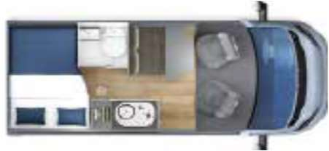
Length  (mt) | Chassis |  | Engine | Wheelbase  (mm) | End-user price without  VAT (€)
5,41 |  |  | 33L 120 hp | 3450 | 37.250
5,41 |  |  | 33L 120 hp | 3450 | 38.900
GIOTTIVAN 60B
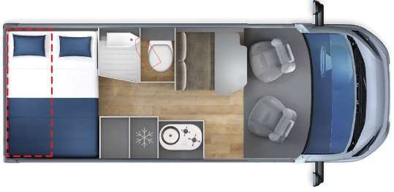
Length  (mt) | Chassis |  | Engine | Wheelbase  (mm) | End-user price without  VAT (€)
5,99 |  |  | 33L 120 hp | 4035 | 39.200
5,99 |  |  | 33L 120 hp | 4035 | 40.850
GIOTTIVAN 60T
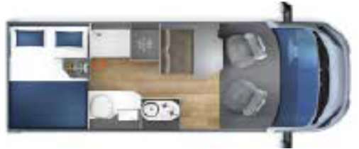
Length  (mt) | Chassis |  | Engine | Wheelbase  (mm) | End-user price without  VAT (€)
5,99 |  |  | 33L 120 hp | 4035 | 38.850
5,99 |  |  | 33L 120 hp | 4035 | 40.500
Packs |  |  |  |  | End-user price without VAT (€)
Chassis 35L |  |  |  |  | 833
Overprice 140hp |  | 833
Pack VAN |  | 1.750
Pack PRIVILIEGE |  | 2.050
Pack PLUS |  | 470
Price list reserved at the sole use of the Gioƫline sales network - The prices are ex-works and not including the costs of registration - This price list is valid till revocation - Giottiline Compnay S.p.A. reserves the right to change the above mentioned data with no notice - charge of €70,00 for the vehicle preparation


GIOTTIVAN Packs 2022/2023

Pack VAN |  | Retail price
Cabin Air-conditioner |  | 3.300 €
Start & Stop |  | 3.300 €
Traction +, Hill Holder, Hill Descent
Co-driver airbag
Electric and heated rear-view mirrors
Paint bumper
Cruise control
Radio provision
Truma CP Plus with iNET provision
Slatted bedsteads
Additional berth in the dinette
Fog-lights
Spare key with remote control
End-user special price
without VAT
 |  | 1.750 €
Saving for the customer: |  | 1.550 €

Pack PRIVILEGE VAN |  | Retail price
Sprint or Lounge upholstery |  | 3.000 €
Cabin seat covers |  | 3.000 €
Electric extractable step
Flyscreen by the entrance door
Reverse camera with 7" monitor
Pleated cabin blind
LED outer lamp
End-user special price
without VAT
 |  | 2.050 €
Saving for the customer: |  | 950 €

*Pack PLUS PSA/FIAT: leather-covered steering wheel and gear knob, automatic lights power-on and automatic rain sensor, dashboard chrome decorations and aluminum-style air vents

