SIENA
Price list T1 2022-2023

EUROPE Validity from the 1st of July, 2022

Model | Layout | Engine | End-user price  without VAT (€)

Coach-built


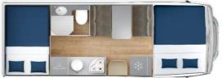
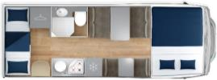
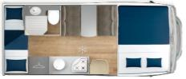
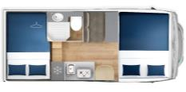



SIENA 422 |  |  | Jumper/Boxer  3.5T 140hp 6.3 | 44.600
SIENA 422 |  |  | Ducato 3.5T  140hp 6.3 | 46.250
SIENA 440 |  |  | Jumper/Boxer  3.5T 140hp 6.3 | 47.400
SIENA 440 |  |  | Ducato 3.5T  140hp 6.3 | 49.050

Low-profile


SIENA 322 | 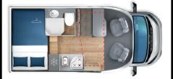 |  | Jumper/Boxer  3.5T 140hp 6.3 | 43.600
SIENA 322 |  |  | Ducato 3.5T  140hp 6.3 | 45.250
SIENA 330 |  |  | Jumper/Boxer  3.5T 140hp 6.3 | 43.600
SIENA 330 |  |  | Ducato 3.5T  140hp 6.3 | 45.250
SIENA 350 | 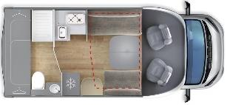 |  | Jumper/Boxer  3.5T 140hp 6.3 | 46.400
SIENA 350 |  |  | Ducato 3.5T  140cv 6.3 | 48.050
SIENA 385 | 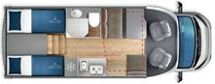 |  | Jumper/Boxer  3.5T 140hp 6.3 | 45.600
SIENA 385 |  |  | Ducato 3.5T  140hp 6.3 | 47.250
SIENA 390 | 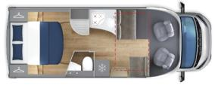 |  | Transit 3.5T  130cv 6.3 | 46.700
390 PREMIER EDITION |  |  | Transit 3.5T  170hp 6.3 AUT | 52.900
SIENA 395 | 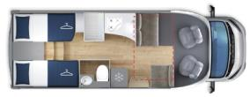 |  | Transit 3.5T  130hp 6.3 | 46.700
395 PREMIER EDITION |  |  | Transit 3.5T  170cv 6.3 AUT | 52.900
SIENA 397 | 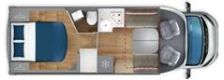 |  | Transit 3.5T  130hp 6.3 | 47.100
397 PREMIER EDITION |  |  | Transit 3.5T  170hp 6.3 AUT | 53.300

Pack End-user price without VAT (€)
Pack Siena 1.750
Pack Privilege (coach-built)* 917
Pack PRIVILEGE (low-profile)* 1.250
Pack PERFORMANCE (FORD)* 825
pull-down bed (standard on the Siena-350) 825
Pack PLUS PSA/FIAT* 630


Price list reserved at the sole use of the Giottiline Company sales network - The rates are in Euro, ex-works and not including the costs of registration - This price list is valid till revocation - GIOTTILINE COMPANY S.p.A. reserves the right to change the above mentioned data with no notice - Charge of €70,00 for the vehicle preparation

Pack SIENA |  | € 3.490
Cabin air-conditioner |  | € 3.490
ESP, TRACTION+ , HILL HOLDER and HILL DESCENT
Start & Stop
Cruise Control
16" steeI wheels
Reinforced suspensions
Radio provision
Radio with steering wheel controls (only FORD)
Paint bumper (available on FORD with Pack PERFORMARCE only)
Co-driver airbag
Cabin seats covers
Heated waste-water tank
Flyscreen by the entrance door
Slatted bedsteads
Outer LED lamp
Truma CP Plus with iNET provision |  | End-user price without  VAT (€)
 |  | € 1.750
Saving for the customer: € 1.740

Pack PRIVILEGE (coach-built models): rear LED lights; entrance door with two locks, panoramic window and centralized locking; reverse camera with monitor; Privilege upholstery
Pack PRIVILEGE (low-profile): front opening skylight; rear LED lights; entrance door with two locks, panoramic window and centralized locking; reverse camera with monitor; Privilege upholstery
*Pack PLUS PSA/FIAT: fog-lights, leather-covered stearing wheel and gear knob, rain sensor, dashboard chrome decorations and aluminum-style air vents
*Pack PERFORMANCE Ford: 170hp engine, fog-lights, paint front bumper
*SIENA PREMIER EDITION Ford: Pack Siena, Pack Privilege, Pack Performance, automatic gearbox, 16" black alloywheels, Radio
2DIN Zenec, DRL LED + Xenon, pleated-cabin blinds, sink cover in the kitchen

