THERRY Price list T1
Season 2022-2023

Europe Validity from the 1st of July, 2022

Model | Layout | Engine | End-user price without VAT (€)




Coach-built


Therry T45 |  |  | Jumper/Boxer 3.5T  140 hp 6.3 | 53.650
Therry T45 |  |  | Ducato 3.5T 140 hp 6.3 | 55.300

Low-profile


Therry T32 | 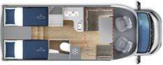 |  | Jumper/Boxer 3.5T  140 hp 6.3 | 53.500
Therry T32 |  |  | Ducato 3.5T 140 hp 6.3 | 55.150
Therry T37 | 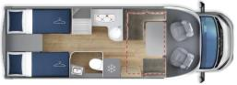 |  | Jumper/Boxer 3.5T  140 hp 6.3 | 54.600
Therry T37 |  |  | Ducato 3.5T 140 hp 6.3 | 56.250
Therry T38 | 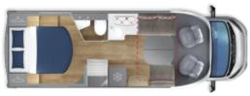 |  | Jumper/Boxer 3.5T  140 hp 6.3 | 55.400
Therry T38 |  |  | Ducato 3.5T 140 hp 6.3 | 57.050

Packs End-user price without VAT (€)
Pack THERRY 1.750
Pull-down bed 825
Pack PLUS PSA/FIAT* 630

Price list reserved at the sole use of the GIOTTILINE COMPANY S.p.A. sales network - The prices are in Euro, ex-works and not including the costs of registration - This price list is valid till revocation - GIOTTILINE COMPANY S.p.A. reserves the right to change the above mentioned data with no notice - charge of €70,00 for the vehicle preparation



Pack THERRY |  | € 3.490
Cabin air-conditioner |  | € 3.490
ESP, TRACTION+ , HILL HOLDER E HILL DESCENT
Start & Stop
Cruise control
16" steel wheels
Reinforced suspensions
Radio provision
Paint bumper
Co-driver airbag
Cabin seat covers
Heated waste-water tank
Electric extractable step
Pleated cabin blinds
Reverse camera with 7" monitor
Truma CP Plus with iNET provision |  | End-user special price without  VAT
€ 1.750
Saving for the customer: € 1.740

*Pack PLUS PSA/FIAT: fog-lights, leather-covered stearing wheel and gear knob, automatic lights power-on and automatic rain sensor, dashboard chrome decorations and aluminum-style air vents

